SUPPLIER
OF REPLACEMENT GERMICIDAL ULTRAVIOLET LAMPS & SLEEVES

We provide cost-effective solution to your ongoing needs

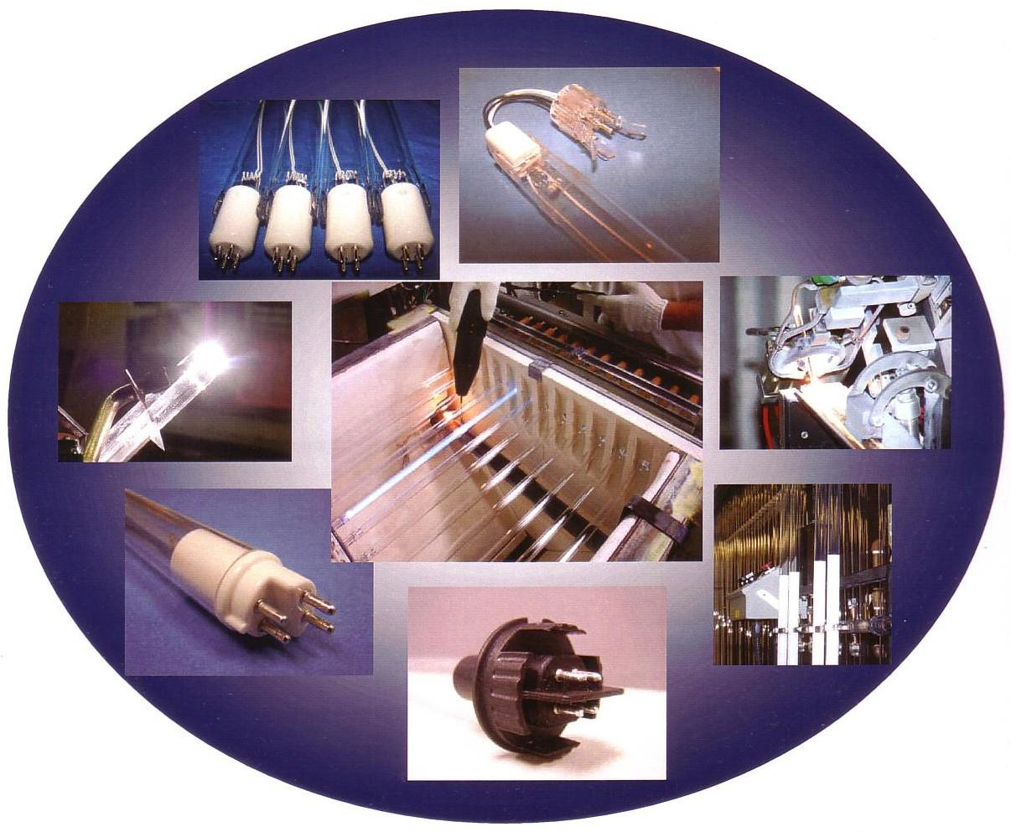

AUSTRALIA
Otava Engineering pty ltd 28 Matthews Square PO Box 334 Ingleburn NSW 2565 Australia
phone : + 61 (0)2 9829 6690 | mobile : + 61 (0) 409 021 286
e-mail : otavaeng@bigpond.com | webpage : www.otava.com.au

INTRODUCTION

Otava - UVS Germicidal UVC lamps are best solution for disinfection and sanitation used in wide range of applications, including water treatment and air surface disinfection, water re reclamation, Swimming/spa pool water, TOC Reduction, Aquaculture, Kitchen hood exhaust purification and deodorization, using ozone producing lamps..
We specialize in supplying of replacement low-pressure standard and amalgam UVC lamps operating on 185 (Ozone Producing) and 254 nm wavelengths, for usage in disinfection chambers and channels of the municipal wastewater plants, industrial process water and drinking water treatment plants, kitchen hood exhaust systems.
The lamps and sleeves are made by our manufacturing facility in Melbourne, adhering to the international quality standards. Our company has the most modern machines, 40 years of experience in this field and proven track record of continuous technical product improvements and developments of new technologies. We have a list of loyal satisfied customers in Australia and other parts of the world.
Our lamps and sleeves are designed and manufactured so that they precisely fit to the vast majority of UV disinfection plants designed and built by world leading companies, such as UDC, Trojan, ITT, Wedeco, Fisher Porter, etc., and fully replace the originally installed units, but at much lower costs. We don’t only supply high-quality components proven in many installations over long periods, but also provide ongoing ”direct-from-the-manufacturer” service and technical backup. Our main focus is on :

Very competitive pricing  Supply of lamps tailored to our customers’ needs | “Plug & Play” compatibility  Reliable ongoing customer service & technical support

REPLACEMENT GERMICIDAL UVC LAMPS
Our germicidal lamps are manufactured from 99.9% pure fused glass, thus allowing maximum transmission of the required UV rays.

STANDARD TYPES - BASIC RANGE

INSTANT-START LAMPS
 | Total | Arc | Lamp | E l e c t r i c a l V a l u e s |  |  | UVC | UV Intensity | Lamp
 | Length | Length | Dia | Voltage | Current | Input | Output | @ 1 m | Life
Lamp Type | [mm] | [mm] | [mm] | [V] | [A] | [W] | [W] | [μW / cm2] | [hrs]
G357T15N DEMinBP | 357 | 281 | 15 | 51 | 0.425 | 17 | 5.7 | 56 | 9 000
G36T15N DEMedBP | 843 | 767 | 15 | 100 | 0.425 | 42 | 14.4 | 150 | 9 000
GHOT15N DEMedBP | 843 | 767 | 15 | 95 | 0.800 | 75 | 25.0 | 240 | 9 000
G60T15N DEMedBP | 1554 | 1478 | 15 | 175 | 0.450 | 75 | 30.0 | 260 | 9 000
GHOT15N DEMedBP | 1554 | 1478 | 15 | 180 | 0.800 | 145 | 48.0 | 385 | 9 000

PREHEAT-START LAMPS
36
HO/
T5LCA/
C
64
HO/
T5LCA/
C
 | Total | Arc | Lamp | E l e c t r i c a l V a l u e s |  |  | UVC | UV Intensity | Lamp
 | Length | Length | Dia | Voltage | Current | Input | Output | @ 1 m | Life
Lamp Type | [mm] | [mm] | [mm] | [V] | [A] | [W] | [W] | [μW / cm2] | [hrs]
G6T15N SE4P | 212 | 136 | 15 | 28 | 0.425 | 12 | 2.8 | 27 | 9 000
GHOT15N SE4P | 212 | 136 | 15 | 23 | 0.800 | 18 | 5.0 | 50 | 9 000
G8T15N SE4P | 287 | 211 | 15 | 40 | 0.425 | 17 | 4.0 | 40 | 9 000
GHO8T15N SE4P | 287 | 211 | 15 | 34 | 0.800 | 27 | 7.5 | 75 | 9 000
G357T1N SE4P | 357 | 281 | 15 | 51 | 0.425 | 17 | 5.7 | 56 | 9 000
GHOT15N SE4P | 357 | 281 | 15 | 40 | 0.800 | 32 | 10.0 | 95 | 9 000
G436T15N SE4P | 436 | 360 | 15 | 62 | 0.425 | 26 | 7.3 | 72 | 9 000
GHO436T15N SE4P | 436 | 360 | 15 | 53 | 0.800 | 42 | 13.5 | 125 | 9 000
G36T15N SE4P | 842 | 762 | 15 | 113 | 0.425 | 48 | 13.5 | 125 | 9 000
GHO36T15N SE4P | 842 | 723 | 15 | 100 | 0.800 | 80 | 29.0 | 265 | 9 000
HIGH-OUTPUT LAMPS
 |  | Total | Arc | Lamp | E l e c t r i c a l V a l u e s |  |  | UVC | UV Intensity | Lamp
 | Spec. | Length | Length | Dia | Voltage | Current | Input | Output | @ 1 m | Life
Lamp Type | No. | [mm] | [mm] | [mm] | [V] | [A] | [W] | [W] | [μW / cm2] | [hrs]
GHO36T15N SE4P | 2758 | 842 | 723 | 15 | 100 | 0.8 | 80 | 29 | 265 | 12 000
GHO60T15N SE4P | 2590 | 1554 | 1434 | 15 | 180 | 0.8 | 145 | 50 | 425 | 12 000
GHO60T15VH SE4P | 2468 | 1554 | 1434 | 15 | 180 | 0.8 | 145 | 50 | 425 | 12 000

High-Output Lamp Configuration is available for all our types and these lamps will deliver up to 80% higher UV output than standard units. They can be fitted with the standard H-O filament or our long-life electrode.
High-Output Filaments are usually operated at higher current – between 600 and 1200 mA.
Long-Life Filaments are of a single piece construction, offer greater durability and help to reduce the occurrence of premature burnout. They also generate higher UV output than the conventional type.

INDIUM AMALGAM LAMPS
Our Amalgam Lamps deliver up to three times the UVC output of the standard low-pressure UVC types and are a cost- effective alternative to the medium-pressure lamps. They are designed to operate efficiently at higher operating temperatures than standard and H-O lamps, thus delivering greater efficiency and / or requiring lower initial equipment cost. The main features include:
Greater stability of UVC output over varying temperatures. Increased UV dosage at given size of the chamber / channel.
Higher efficiency = fewer lamps needed = lower initial equipment costs for the whole system.

OUR BASIC RANGE
 |  | Total | Arc | Lamp | E l e c t r i c a l V a l u e s |  |  | UVC | UV Intensity | Lamp
 | Spec. | Length | Length | Dia | Voltage | Current | Input | Output | @ 1 m | Life
Lamp Type | No. | [mm] | [mm] | [mm] | [V] | [A] | [W] | [W] | [μW / cm2] | [hrs]
G36T15N A90 SE4P | 2133 | 843 | 770 | 15 | 80 | 1.5 | 120 | 35 | 320 | 12 000
G60T15N A90 SE4P | 2360 | 1554 | 1483 | 15 | 135 | 1.5 | 200 | 65 | 500 | 12 000
G36T19N A90 SE4P | 2524 | 843 | 660 | 19 | 75 | 2.0 | 150 | 43 | 400 | 12 000
G60T19N A90 SE4P | 2915 | 1554 | 1483 | 19 | 120 | 2.0 | 240 | 85 | 650 | 12 000
G60T19N A90 SE4P | 2898 | 1554 | 1483 | 19 | 150 | 2.2 | 320 | 105 | 750 | 12 000
G60T28N A90 SE4P | 2994 | 1554 | 1470 | 28 | 100 | 3.5 | 350 | 125 | 950 | 12 000
Note : UV output is measured under laboratory conditions at 253.7 nm for the period of 100 hours. (Actual output in the plant may somewhat vary depending on the actual operating conditions.)
Total length is measured between the outer edges of the bases, but not including electrical contact pins.

OUR REPLACEMENT LAMPS – COMPATIBILITY WITH OEM MANUFACTURERS

 |  | O u r L a m p |  |  | Q u a r t z S l e e v e
 | Disinfection |  | Spec. | Length | Dimensions | Ends
OEM Model | System | Type | No. | [mm] | [mm] | First / Second
UDC
5340 UD |  | G36T5LCA/CB-0L0 | 3055 | 843 | 22x24.5x892 | Domed / Open
9410 UD |  | G64T5LCA/CB-0L0 | 3061 | 1554 | 22x24.5x1588 | Domed / Open
19905 UD |  | G64T5VHCA/2S07/CB-0L0 | 2782 | 1554 | 22x24.5x1588 | Domed / Open
TROJAN |  |  |  |  |  | Open / Open
600080 | 2000 | G64T5LCA/C | 1993 | 1554 | 20x23x1562
302418 | 3000 | G64T5LCA/2TC | 1886 | 1554 | 20x23x1610 | Domed / Open
302317 | 8000 | G64T5LCA/S16/2TC | 2678 | 1554 | 20x23x1610 | Domed / Open
302509 | 3000+ | GIA1564T6LCA/2S13/CB-021 | 2940 | 1564 | 25x28x1950 | Domed / Flared
793923 |  | GIA1002T6LCA/2S13/CB-021 | 2932 | 1002 | 25x28x1016 | Domed / Flared
794113 |  | GIA672T6LCA/2S13/CB-21 | 2933 | 672 | 25x28x699 | Domed / Flared
IDI
 |  | G64T5LCA/PT-3”/2W/B/C | 2551 | 1554 | 22x24.5x1626 | Domed / Open
59619-G09 | Aquaray 40 VLS | G64T5LCA/PT-18”/2W/B/C | 3095 | 1554 | 22x24.5x1702 | Domed / Open
 |  | G64T5 LCA/PT-24“/2W/B/C | 2577 | 1554 | 22x24.5x1702 | Domed / Open
61645-G10 | Aquaray 40 HO VLS | G64T5LCA/S16/PT-18”/2W/B/C | 2026 | 1554 | 22x24.5x1702 | Domed / Open
WEDECO / ITT
SLR2581 |  | GIA881T8LCA/2S18/CB-006 | 2022 | 881
SLR25113 |  | GIA1200T8LCA/2S18/CB-006 | 2015 | 1200
SLR25143 |  | GIA1500T8LCA/2S18/CB-006 | 2016 | 1500
XLR-20 |  | GIA985T9LCA/2S18/CB-024 | 3105 | 985
SLR32143 | TAK55 | GIA1495T10LCA/2S18/CB-012 | 3119 | 1495 | 44x48x1514A01
SLR32143HP |  | GIA1512T9LCA/2S18/CB-012 | 2848 | 1512 | 44x48x1514A01
XLR-30 | XLB | GIA1512T9LCA/2S18/CB-024 | 3027 | 1512 | 44x48x1514A01
FISHER PORTER
B1538008U011 |  | G64T5LCA/4CI | 2530 | 1554 | 22x24.5x1610 | Domed / Open
Disclaimer : Neither Trojan Technologies, IDI, WEDECO nor FISHER PORTER have sponsored, endorsed or approved these or any other replacement lamp.

QUARTZ SLEEVE FABRICATION
Our sleeves are manufactured from 99.9% pure fused quartz. These materials allow maximum UV transmission of the UV rays and provide increased wear resistance.
Quartz sleeves – main features:

- Available in a wide variety of lengths and diameters.  - Cut to the required lengths. | - Bent, polished, spliced, flared – as per requirements from individual customers.  - Other additional production operations are also available upon request.

ADDITIONAL INFORMATION

LONG-LIFE COATED LAMPS versus STANDARD UNCOATED – COMPARISON :
We also offer a full range of germicidal lamps with internal coating. This coating functions as a barrier between mercury vapors and the internal surface of the lamp tube, making the lamp more resistant against “solarization” (= darkening”) thus resulting in the following benefits for the customers :

- Extended life and more constant performance over the whole life of the lamp.  - Higher UVC output and intensity toward the end of the life cycle. | - Reduced mercury content.  - Lower equipment costs by lower number of lamps required.

VALUE-ADDED SERVICES TO OUR CUSTOMERS:
  - PROPRIETARY CERAMIC BASES … We have accumulated a wide range of tooling for the standard plastic and ceramic bases, so it is highly that we already have the configuration you’ve been using. In addition to this, we are able to design and produce any new types of bases you may require. Our in-house capabilities allow us to :

- Easily and effectively determine each specific product.  - Match the required pin configuration. | - Substantially reduce the lead-time from the initial design to actual production.

  - MARKING OF LAMP TUBES … As a standard, we etch each lamp tube with a code showing the date of manufacture and caution remark. If you require any additional marking - please let us know.
  - MARKING OF LAMP BASES … Each base can be marked with a variety of information, e.g. logo, product number, country of origin, re-order information, etc. For the ceramic basis we use single or multi-color on lay bonded onto the base at high temperature, resulting in durable and clear marking and very good product appearance.
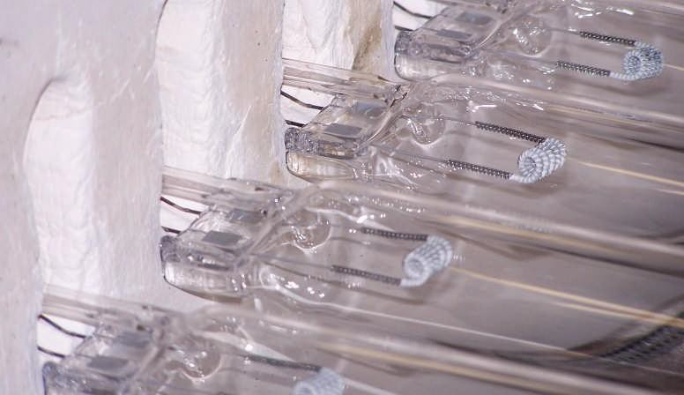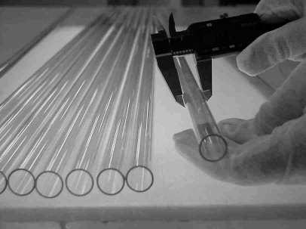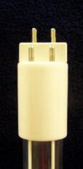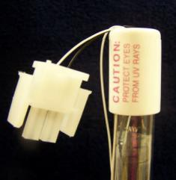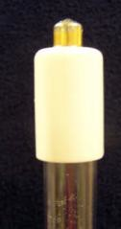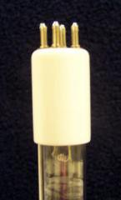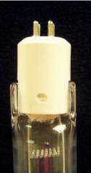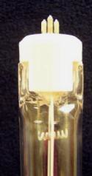Rev12/20

